No woman, no drive
http://www.youtube.com/watch?v=aZMbTFNp4wI
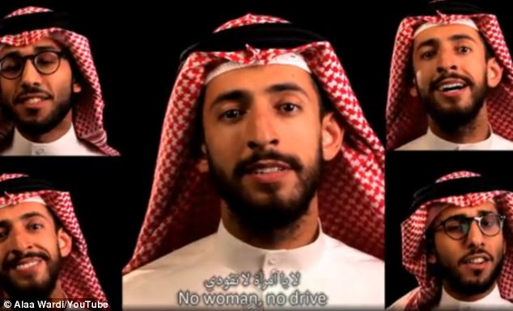

No Woman, No Drive video mocking Saudi Arabia's ban on women drivers goes viral 31 Oct 2013

A music video criticising Saudi Arabia's ban on women drivers has gone viral - with nearly EIGHT million views in less than a week.
No Woman, No Drive, set to the tune of Bob Marley's No Woman, No Cry, was filmed by Saudi comedians and activists.
They sing lyrics such as: "In this bright future you can't forget your past, so put your car keys away."
Hisham Fageeh, an Arab-American comedian living in Saudi Arabia, introduces the video and sings in the film.
In an apparent dig at the country's authorities, he sings a capella - using whistling, finger clicks and beard scratches to make music - as musical instruments are frowned upon by some conservatives.
He also mocks recent comments from a Saudi cleric who claimed driving could damage a woman's ovaries and her chances of having children.
The lyrics say: "I remember when you used to sit in the family car but back seat, ova-ovaries all safe and well so you can make lots and lots of babies."
Currently, Saudi women cannot receive driving licences, although the law does not explicitly say they cannot drive.
The song was released on the same day that women in the country got behind the wheel in protest at the ban.
Campaigners had hoped it would be the biggest day of action so far, but threats of arrest and legal action stopped many from participating.

(from: Mirror.co.uk http://www.mirror.co.uk/news/weird-news/no-woman-no-drive-video-2659219#ixzz2jVVdmbwy)

A few questions on the text

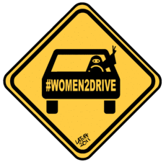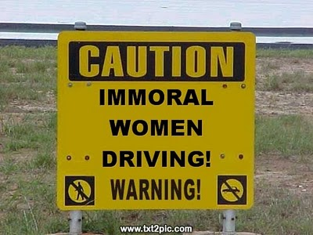

What is the meaning of “to go viral”? ……………………………………………………………………………………………………..
Why does he not use instruments? …………………………………………………………………………………………………………
What was the purpose of the song/ film, in your opinion? ………………………………………………………..……………
Did it reach its goal, according to you? …………………………………………………………………………………………………..
When was the film/song released? Why? ………………………………………………………………………………………………
How does he mock the religious authorities? …………………………………………………………………………………………

