Drive My Car - The Beatles
http://www.youtube.com/watch?v=8Ts2U1mkfz4
Do you know this song by The Beatles? Do you like it?
Before listening to the song, look at the lyrics and put them in the right order.

I told the girl that my prospects were good
And she said baby, it's understood
Working for peanuts is all very fine
But I can show you a better time
refrain
Asked a girl what she wanted to be
She said baby, can't you see
I want to be famous, a star on the screen
But you can do something in between
refrain
I told the girl I can start right away
And she said listen babe I got something to say
I got no car and it's breaking my heart
But I've found a driver and that's a start
refrain
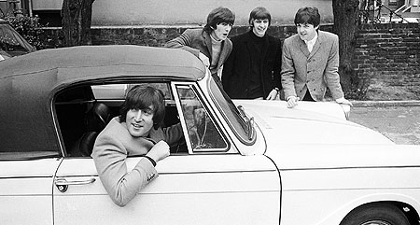
refrain:
Baby you can drive my car
Yes I'm gonna be a star
Baby you can drive my car
And maybe I'll love you
Beep beep'm beep beep yeah
Beep beep'm beep beep yeah
Beep beep'm beep beep yeah
Beep beep'm beep beep yeah

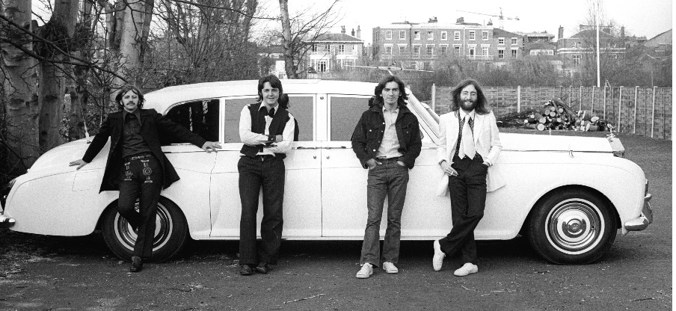

What do you think this song is about?
The comments below can be found on the internet. Which one comes nearest your own interpretation?
1) This song has always been my absolutely favourite song and it will always be. It's not that kind of song you listen to 10 times a day and after a week you hate it, no it's a song you totally enjoy to listen to from time to time…

2) According to me, simple as it is, the song still covers very strongly the mindset of girls and it’s still valid even in today's generation. The point being very simple, girls like their own space with things, otherwise they feel very choked. It’s a whole view on the beginning of woman's liberation and all that jazz. That is when women started to realize how powerful they can be and the strong role that they can play in society. And considering how The Beatles had and still continue to have such a huge female fan following, they probably didn't want to piss them off…

3) Why don't we just go by the humour in the lyrics and the irony of the situation.... about a guy who is being used as a stepping stone by a girl who wants to make it big.... it’s so intelligently written.
It’s just that we like to complicate things... one great song and people pounce on it to tear it apart... so just relax, sit back and enjoy :)

From: http://www.sing365.com/music/lyric.nsf/Drive-My-Car-lyrics-The-Beatles/F35CF8B949859F9948256BC2001396B0

