Pablo Picasso (1881-1973)
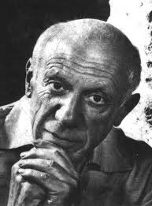
Paintings and pictures:
http://www.google.be/search?q=picasso&hl=nl&prmd=imvns&tbm=isch&tbo=u&source=univ&sa=X&ei=J2vLTtaUAoiUOtDYxa8P&ved=0CE0QsAQ&biw=1920&bih=955
Disfiguring faces and bodies: http://www.youtube.com/watch?v=fjoWCdzhuFI
Picasso at work (in his studio?) painting a mural: http://www.youtube.com/watch?v=ExCQZ940Rbw
Portrait of Gertrude Stein:
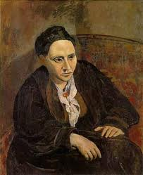
Ernest Hemingway (1899-1961)
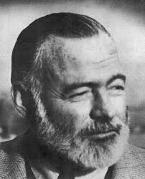

Ernest Hemingway's house and museum in Oak Park, Illinois:
http://www.youtube.com/watch?v=_UXduIferoE

Ernest Hemingway's house in Key West, Florida:
