Modals: can, can’t, must or mustn’t

1 - That's ridiculous- you ____ be joking.

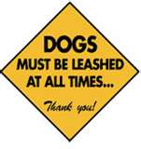
can
must

2 - That's the phone- who ____ it be?

can
must

3 - They haven't eaten for hours- they ____ be starving.

can
must

4 - I'm busy this morning, but I ____ see you this afternoon if you like.

can
must

5 - It ____ be the postman; it's far too early.

can't
mustn't

6 - You ____ enter the country without a visa.

can
must

7 - They're two hours late- there ___ be something wrong.

can
must

8 - She left two hours ago, so she ____ have arrived by now.
can
must

9 - My doctor says I ____ lose some weight.
can
must

10 - ____ you smell something burning?
Can
Must

