House and furniture: describe what you see in the pictures

1) This is a painting of the b........................... of Van Gogh.

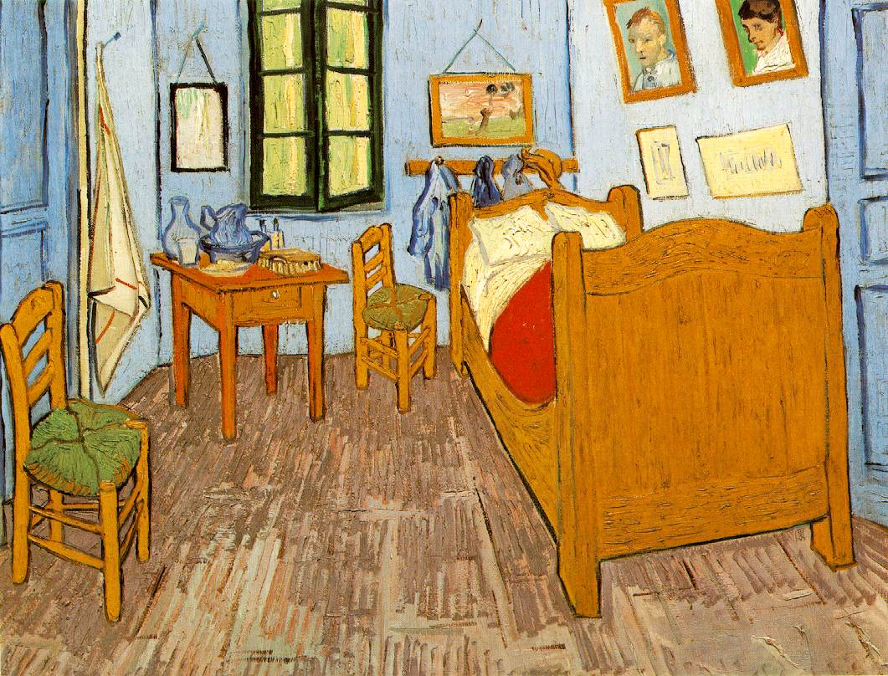
There's one b...... and there are two c............
The w..................... is open. There are two d................., one on the left and one on the right.
There are p........................... on the w................
In the corner there's a small t..................... . There's a m.................... above the t......................... .
There's no r............. on the wooden floor.

2) Now describe what you see in the following pictures.
This is a photo of a l................... r................... . There .........................................
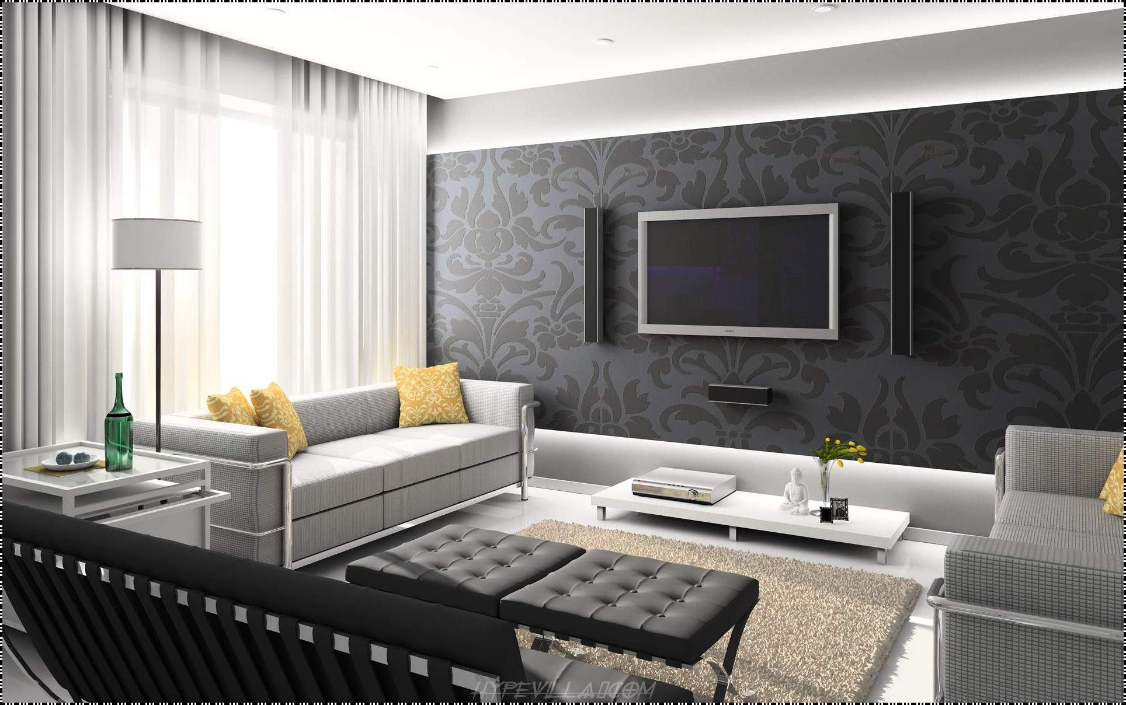

And this is a drawing of a k......................... . There ..........................................
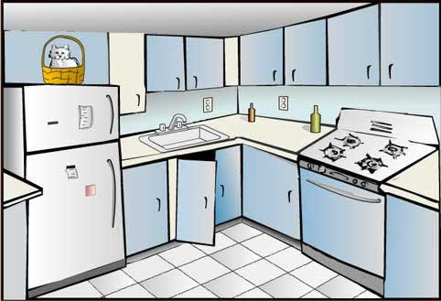
This is a photograph of a b.......................................... . There ...........................................................
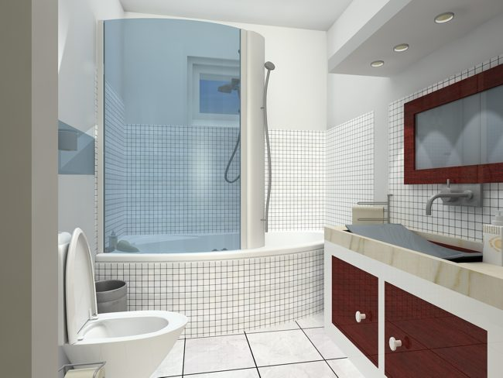

And here's a photo a a d.......................... r................................. . There ........................................
