LONDON BY TUBE
map reading and speaking
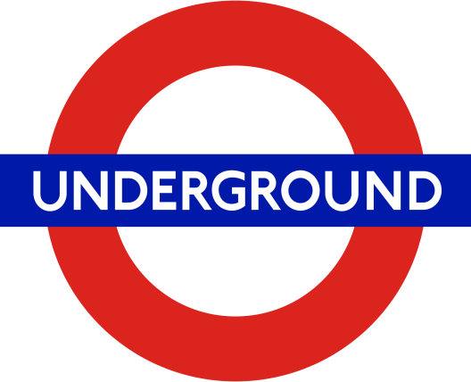

You receive a streetmap and map of the underground.
In groups decide which places you want to visit on a citytrip to London.
Select at least five different places.
Explain why you think they are interesting.
Then start planning your journey.
In which order will you visit the places you want to see?
Make an itinerary, a detailed plan for your journey.
You will have to use a streetmap and a map of the underground.

