LONDON AND NEW YORK
1. Make your own list of tourist attractions in London.
Now watch this video and compare with your own list.

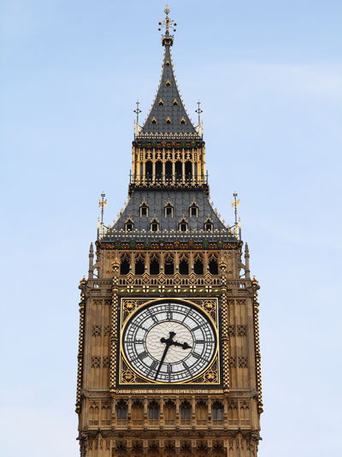
http://www.youtube.com/watch?v=RKNBIitoXMQ
10. St Paul's Cathedral
9. Trafalgar Square
8. Double decker buses
7. Thames
6. Covent Garden
5. Tower of London
4. London Bridge
3. Houses of Parliament
2. Buckingham Palace
1. London Eye

2. Do the same for New York. Which thing are on your to do-list?
Now compare your own top ten with the video.

http://www.youtube.com/watch?v=vA3OuEd4e1c
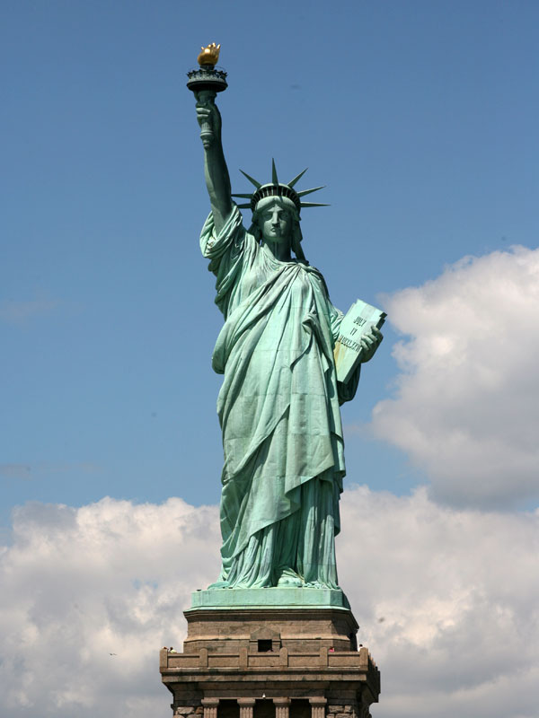
10. Staten Island ferry
9. Brooklyn Bridge
8. Greenwich Village
7. Wall Street
6. Grand Central Terminal
5. Rockefeller Center
4. Central Park
3. Empire State Building
2. Times Square
1. Statue of Liberty

