Good Manners
Good manners: in general
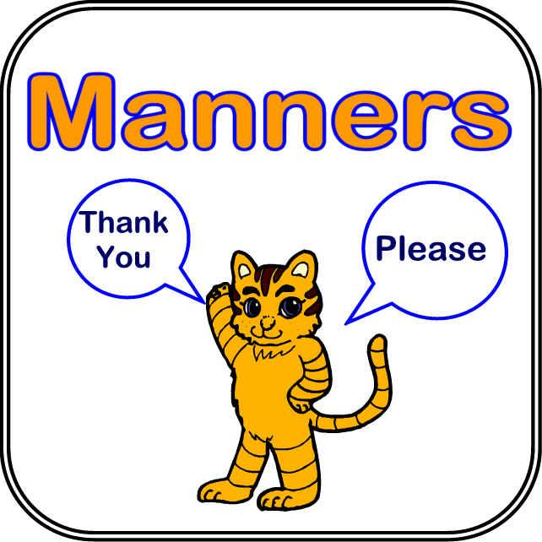
In pairs: discuss what good manners are for you.
What is your top 3 of good manners? Motivate your answer.
-
-
-
Now watch this short film.
http://www.youtube.com/watch?v=bin6cgkcyK8
- What do the children mean by good manners?
- Which things are bad manners?
- What's the advantage of having good manners?

Good manners at the dining table
Discuss in pairs:
Which table manners are important for you? Have you taught your children to observe these rules?
These drawings may give you some inspiration.

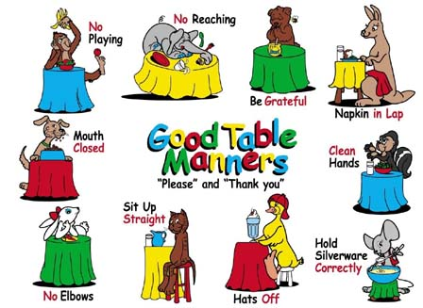
Now watch this 'lesson' on dining table etiquette on youtube.
http://www.youtube.com/watch?v=NDFgw9OkN-k
Which things should be avoided?
KEY : DON'T ...
- move place cards
- take medication
- apply lipstick
- use a tooth pick or your finger to remove s.th. from between your teeth
- use your cell phone
- just talk to the person you came with
- take away a doggy bag
- share bites of your food
- ask for a taste of somebody else's

To conclude:
What do you think of these rules?

